How to Choose a Hoot

One Hoot
Choose one hoot for issues you feel are minor.
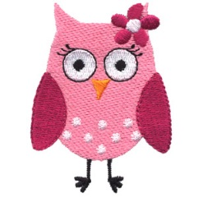
Two Hoots

Choose two hoots if the issue isn’t major, but you really would like to get it resolved soon.

(Friendship concerns, family concerns)
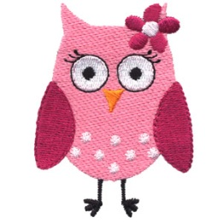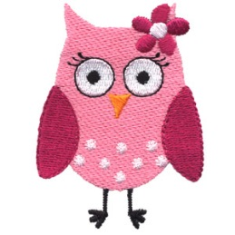
Three Hoots

Choose three hoots if the issue is URGENT! This includes a death in the family (including a pet), major family changes (divorce/separation), bullying,

and sad feelings/depression.
